S3 Bucket Task
Task 1: Create an S3 Bucket and Upload Some Objects (AWS Console)
Step 1: Login
- Login to AWS Console
- Search S3
- Open Amazon S3

Step 2: Create Bucket
Click Create bucket
Fill in:
Field | Value
Bucket name | narayana-demo-bucket-12345 (must be globally unique)
AWS Region | Europe (Stockholm) eu-north-1
Object Ownership | ACLs disabled (Default)
Block Public Access | Leave enabled
Bucket Versioning | Disable
Encryption | SSE-S3 (Default)
Click Create bucket
You should see:
Bucket created successfully
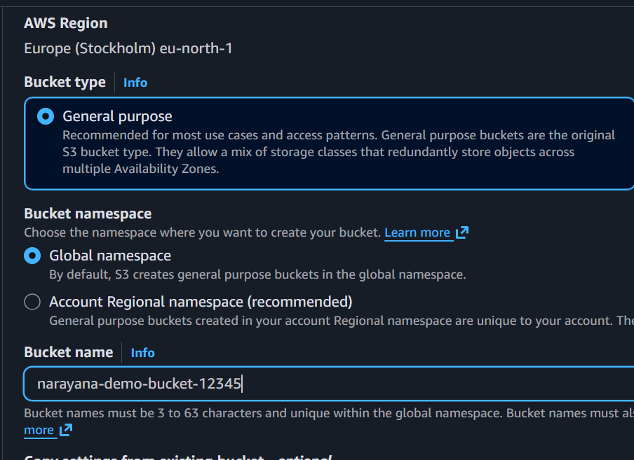
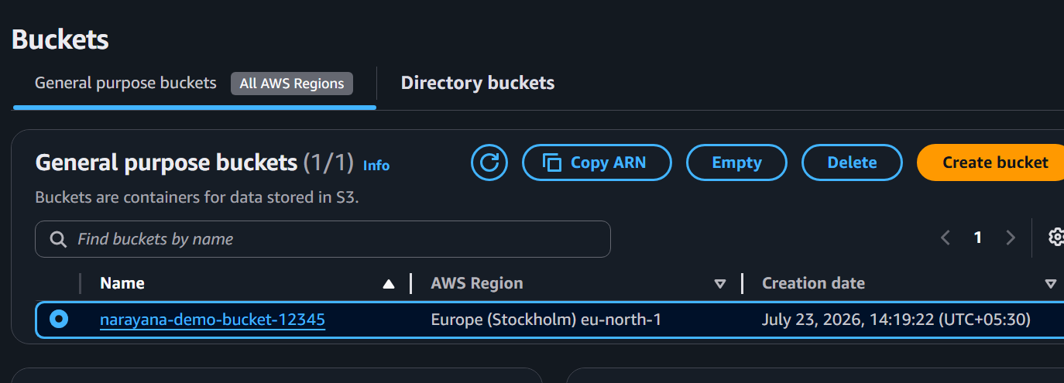

Step 3: Upload Objects
Open the bucket.
Click and Upload
Choose files such as:
file.txt
image.png
Click and Upload
Verify the objects appear in the bucket.
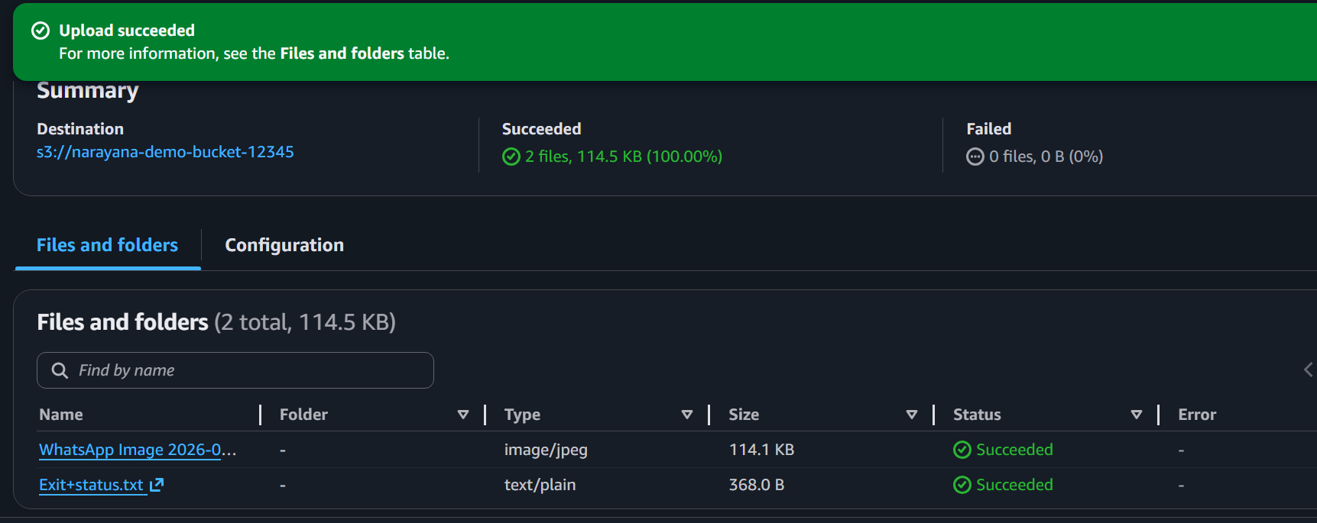
Task 2: Deploy a Static Website (AWS Console)
Step 1: Create Website Files
Create an index.html file on your computer:
<!DOCTYPE html>
<html>
<head>
<title>My Website</title>
</head>
<body>

<h1>Welcome to AWS S3 Static Website</h1>

<p>This website is hosted using Amazon S3.</p>

</body>
</html>
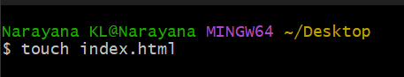
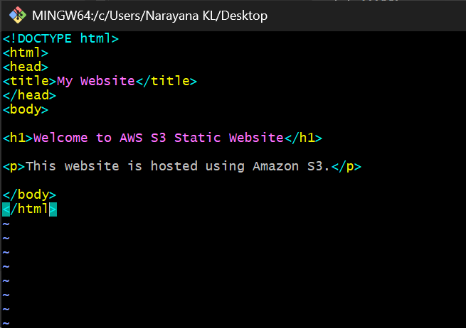

Step 2: Upload Website
Open your bucket.
Click
Upload
Upload
index.html
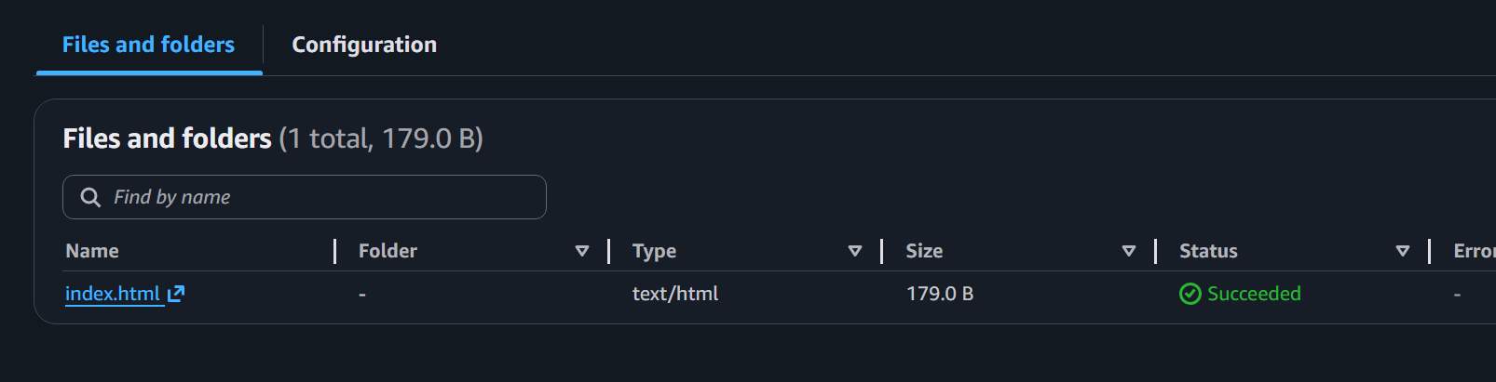

Step 3: Enable Static Website Hosting
Open
Properties
Scroll to
Static website hosting
Click
Edit
Choose
Enable
Hosting type
Host a static website
Index document
index.html
Click
Save Changes
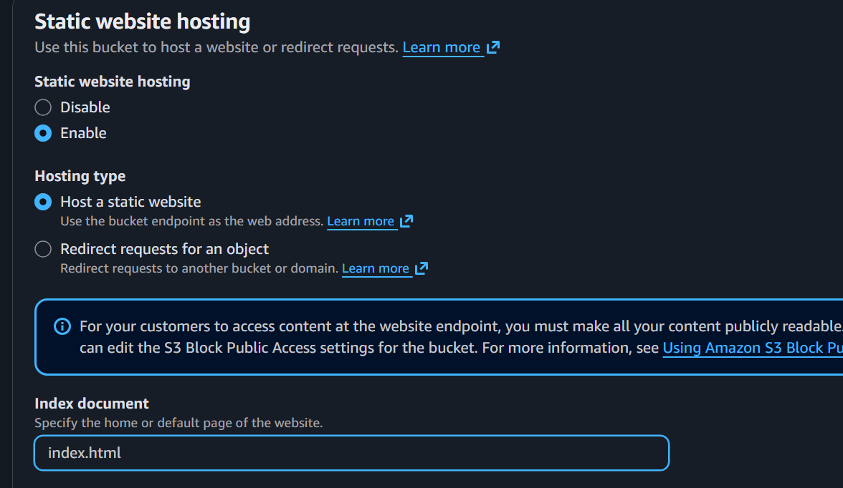

Step 4: Make Website Public
Go to
Permissions
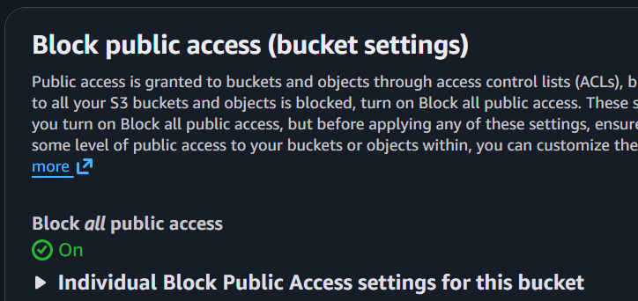
Disable Block Public Access
Click
Edit
Uncheck
Block all public access
Save.
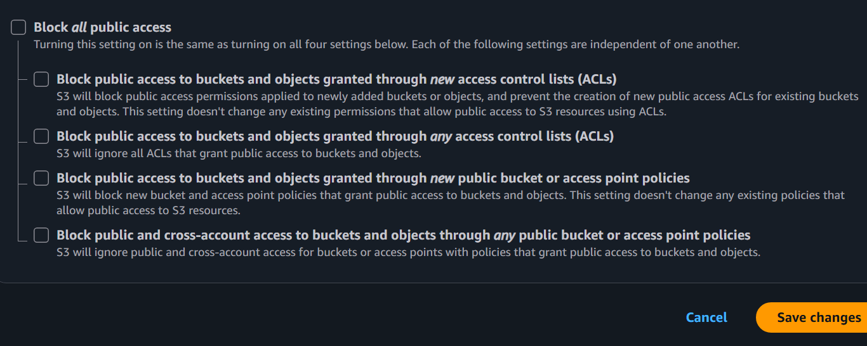
Type
Confirm
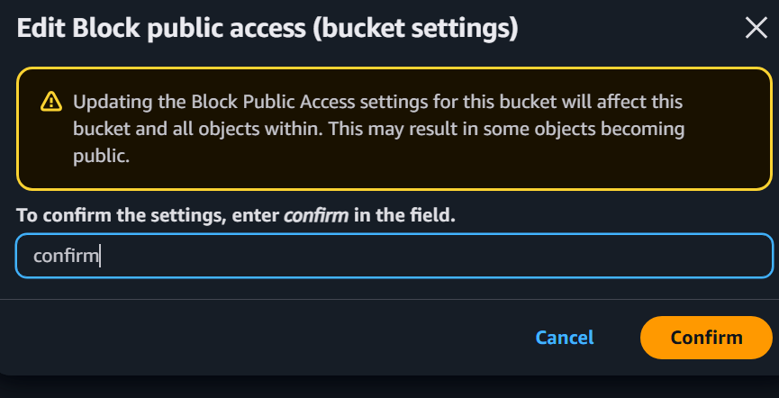
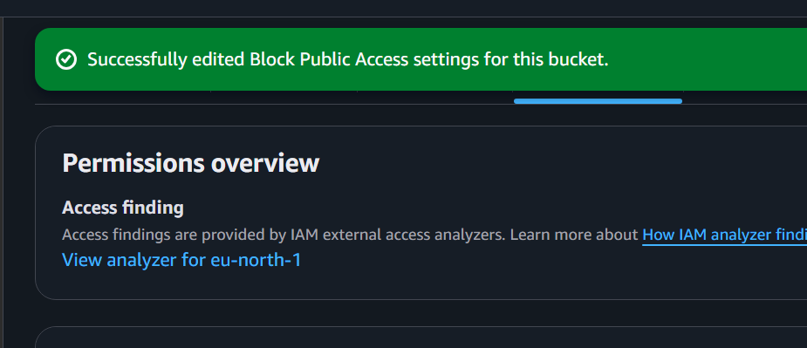

Add Bucket Policy
Bucket Policy
{
"Version":"2012-10-17",
"Statement":[
{
"Sid":"PublicRead",
"Effect":"Allow",
"Principal":"*",
"Action":"s3:GetObject",
"Resource":"arn:aws:s3:::narayana-demo-bucket-12345/*"
}
]
}
Save.
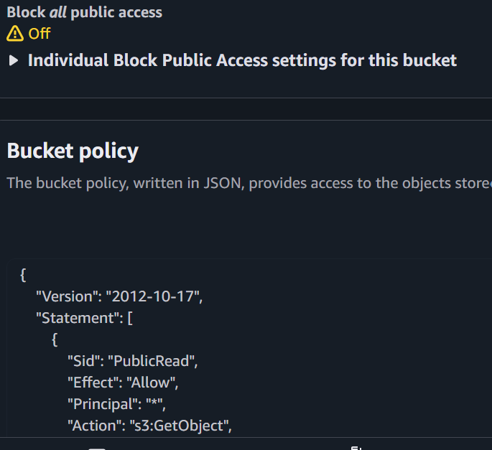
Step 5: Test Website :Go back to
Properties
Copy the
Bucket website endpoint
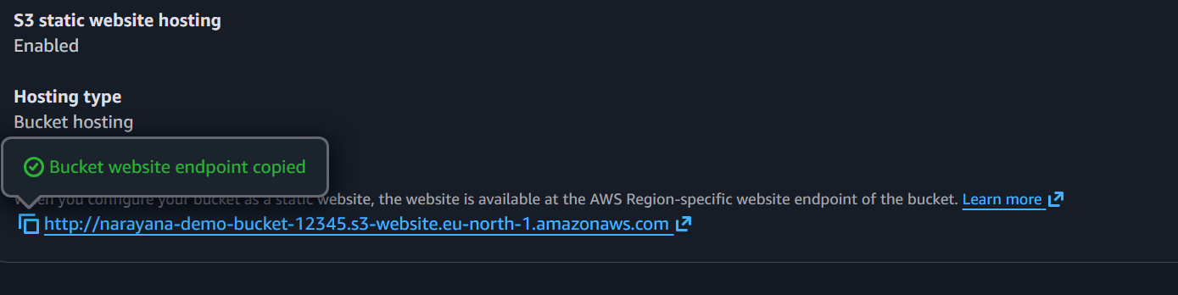
Open it in your browser.
Your webpage should load.
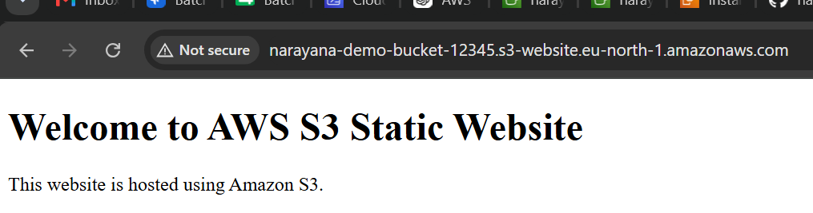
Task 3: Enable Cross-Region Replication (AWS Console)
Step 1: Create Source Bucket
Create a bucket named
narayana-source-bucket
Region
eu-north-1

Step 2: Create Destination Bucket
Create another bucket
narayana-backup-bucket
Region
ap-south-1
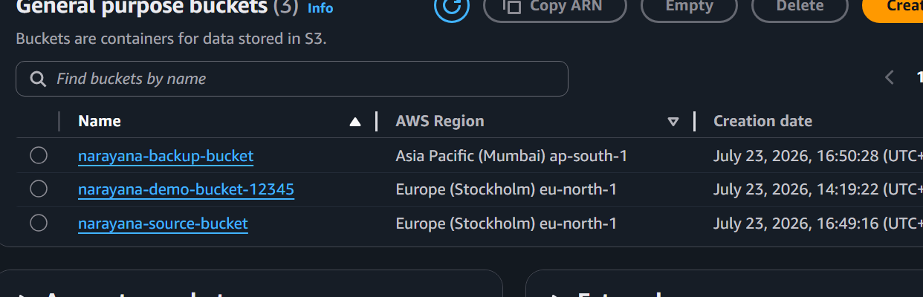

Step 3: Enable Versioning
Open
Source Bucket
Properties
Versioning
Edit
Enable
Save.
Repeat the same for the destination bucket.
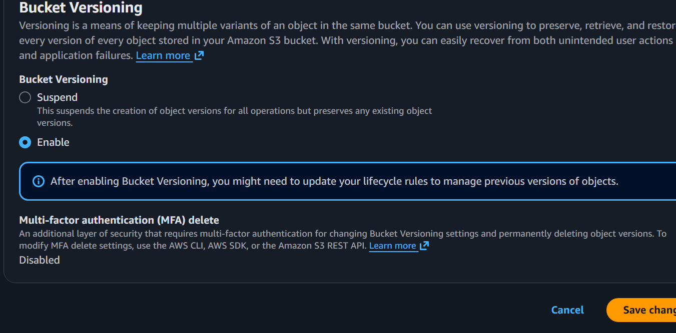

Step 4: Configure Replication
Open
Source Bucket
Go to
Management
Click
Replication rules
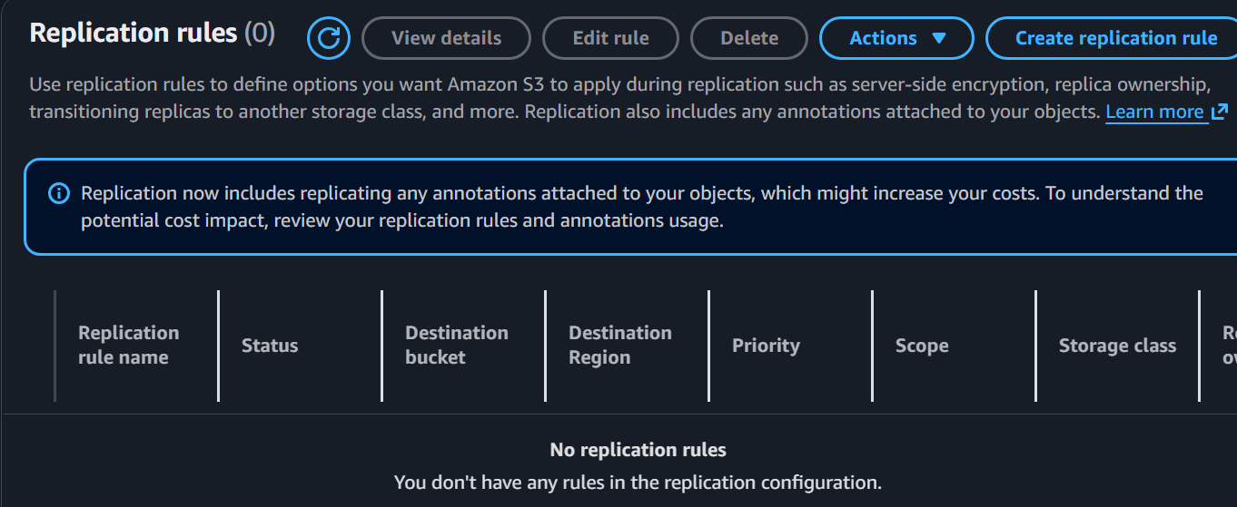
Create replication rule.
Example values:
Option | Value
Rule name | CrossRegionReplication
Status | Enabled
Scope | Entire bucket
Destination | Choose destination bucket
Destination bucket | narayana-backup-bucket
IAM Role | Create new role

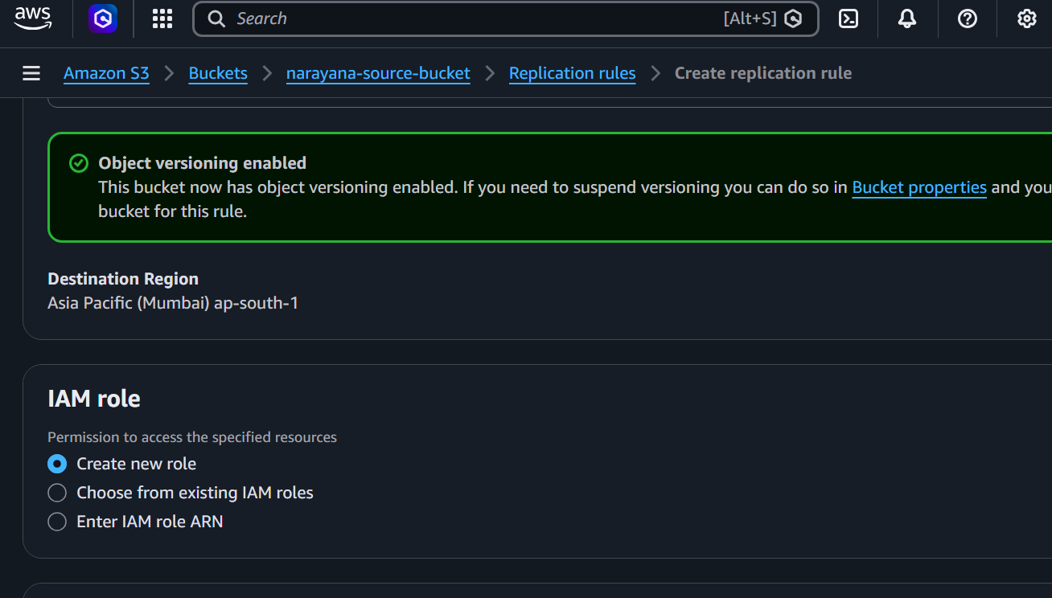
Click
Save

Step 5: Test
Upload a file into the source bucket.
Wait a few minutes.
Open the destination bucket.
The uploaded object should be replicated automatically.
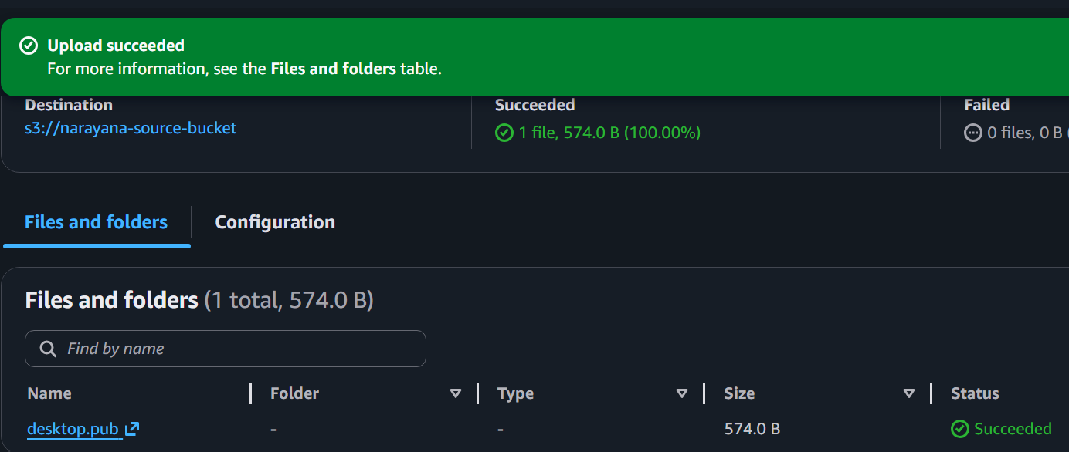
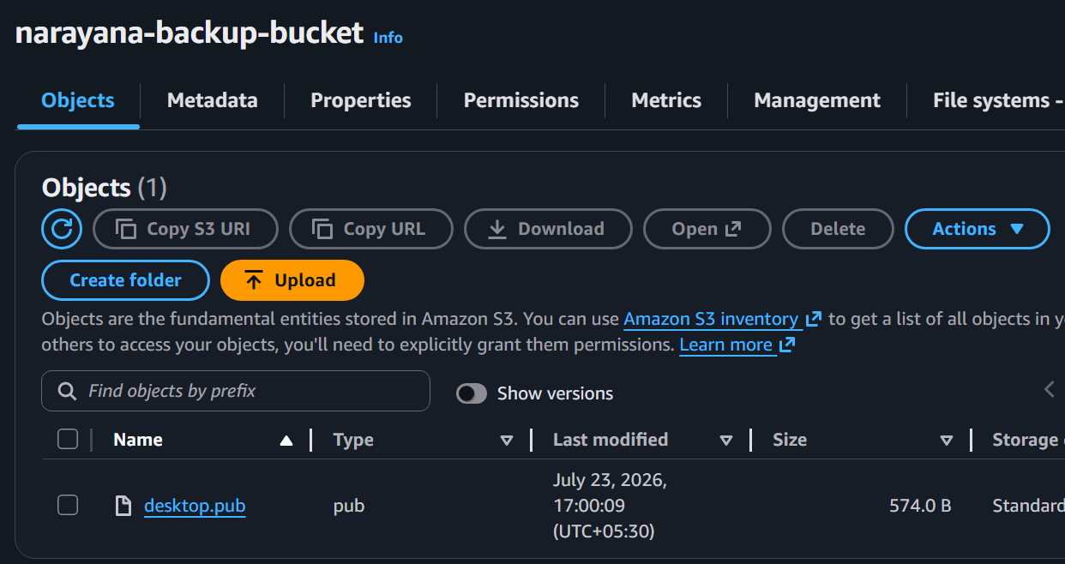

Task 4: Configure Bucket Policy So Only the Admin User Can See Objects (AWS Console)
Open
S3
Select the bucket.
Go to
Permissions
Open
Bucket Policy
Replace the account ID with yours:
{
"Version": "2012-10-17",
"Statement": [
{
"Sid": "AllowAdminOnly",
"Effect": "Allow",
"Principal": {
"AWS": "arn:aws:iam::479368491670:user/Admin"
},
"Action": "s3:*",
"Resource": [
"arn:aws:s3:::narayana-demo-bucket-12345",
"arn:aws:s3:::narayana-demo-bucket-12345/*"
]
}
]
}
Save the policy.
Note: The Admin IAM user must exist, and you may also need to ensure no other IAM policies grant access to this bucket.
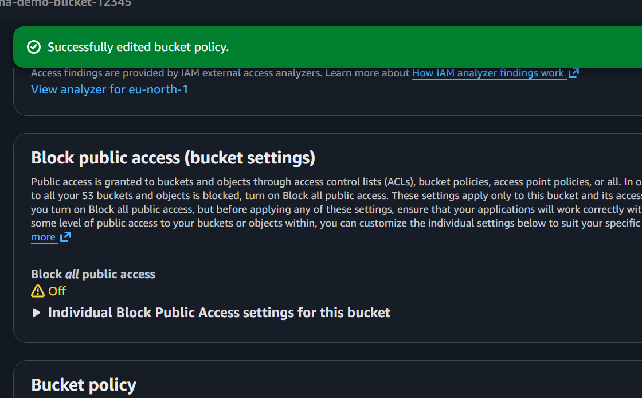
Create an Admin IAM User
- Go to IAM → Users
- Click Create user
- User name:
Admin
- Click Next.
- Select Attach policies directly.
- Attach AdministratorAccess.
- Click Next → Create user.

Step 3: Get Your Account ID
Click your account name (top-right) → Account.
You'll see a 12-digit Account ID, for example:
479368491670
Step 4: Copy the Admin User ARN
Go to:
IAM → Users → Admin
You'll see an ARN like:
arn:aws:iam:: 479368491670:user/Admin
Copy it.

Step 5: Upload Some Files
Open the bucket.
Upload:
sample.txt
photo.jpg
index.html

Step 6: Apply the Bucket Policy
Go to:
S3 → narayana-private-bucket → Permissions → Bucket policy
Paste the following policy (replace the account ID and bucket name):
{
"Version": "2012-10-17",
"Statement": [
{
"Sid": "AllowAdminOnly",
"Effect": "Allow",
"Principal": {
"AWS": "arn:aws:iam::479368491670:user/Admin"
},
"Action": "s3:*",
"Resource": [
"arn:aws:s3:::narayana-demo-bucket-12345",
"arn:aws:s3:::narayana-demo-bucket-12345/*"
]
}
]
}
Replace:
- 123456789012 with your account ID
- narayana-private-bucket with your bucket name
Click Save changes.

Step 7: Test the Policy
Test 1: Sign in as the Admin IAM User
Go to S3.
Open the bucket.
You should be able to:
- ✅ View objects
- ✅ Upload files
- ✅ Download files
- ✅ Delete files

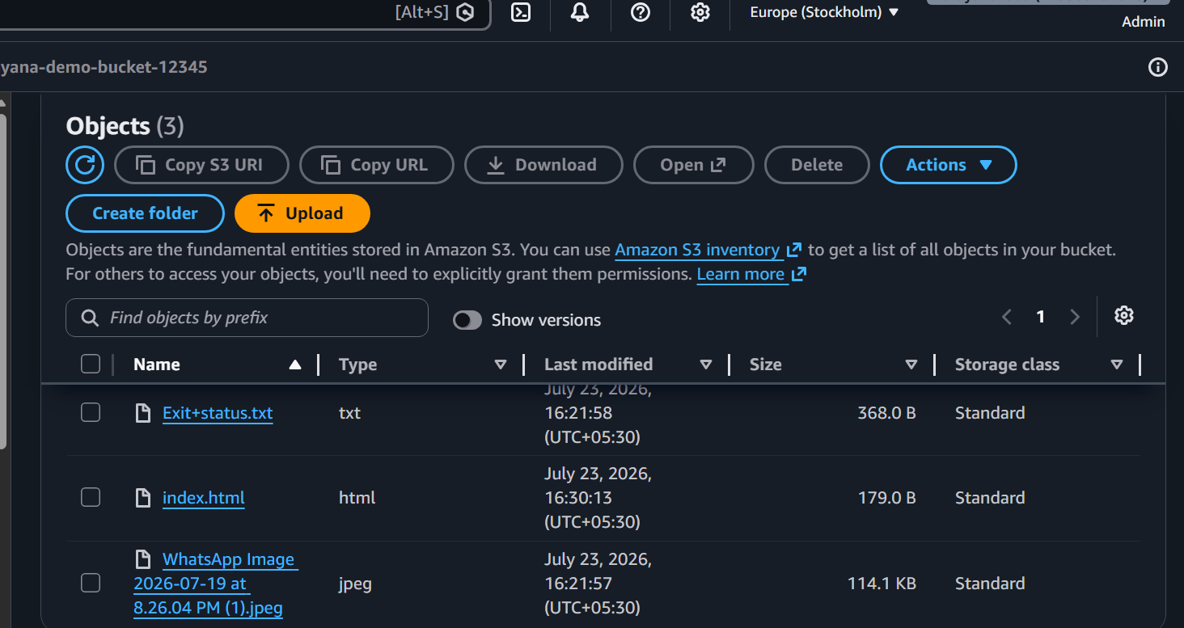
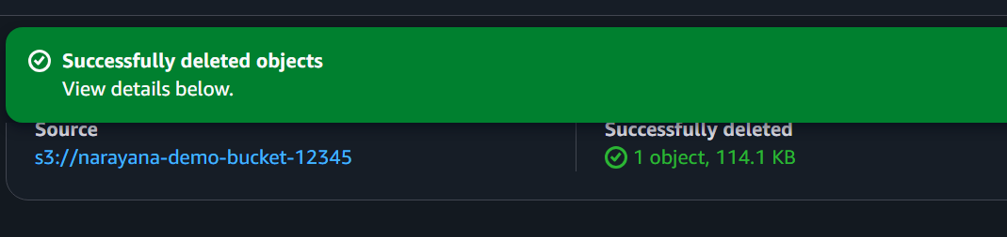

Task 5: Configure Lifecycle Policy (AWS Console)
Open the bucket.
Go to
Management
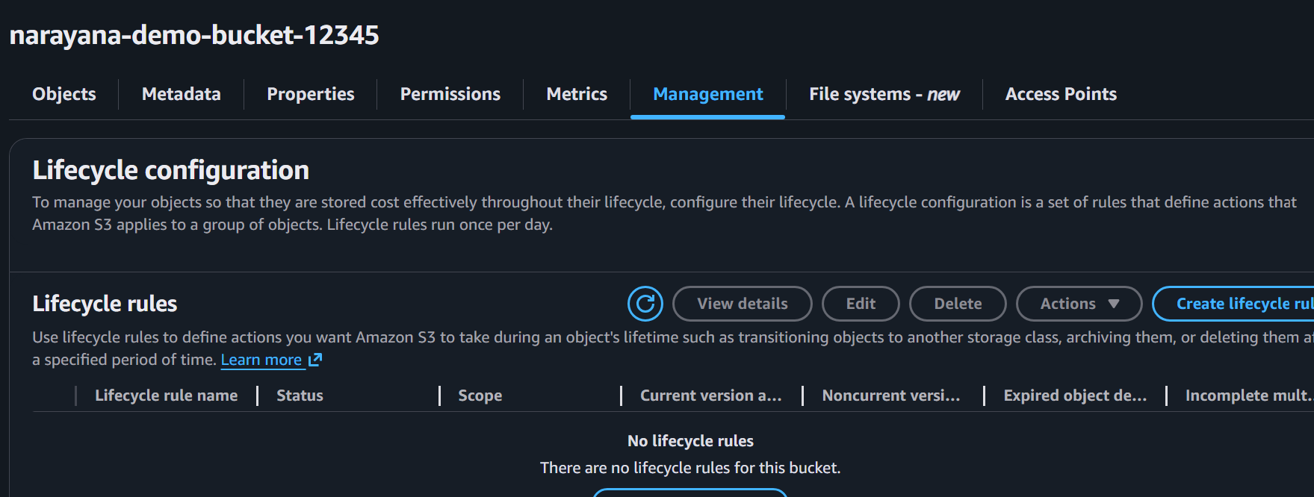
Click
Create lifecycle rule
Example:
Field | Value
Rule name | DeleteOldObjects
Scope | Apply to all objects
Transition | After 30 days → Standard-IA
Transition | After 60 days → Glacier Instant Retrieval
Expiration | Delete after 365 days
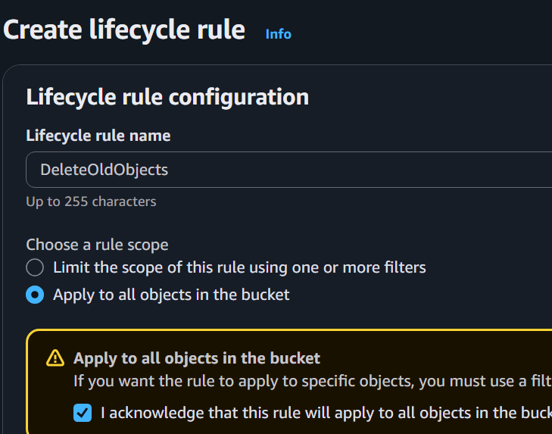
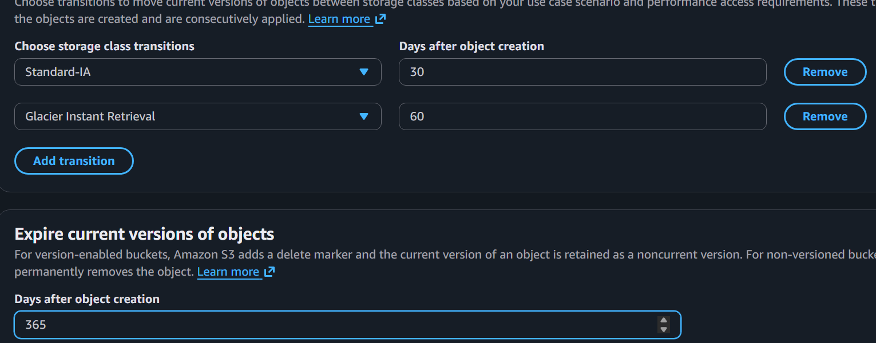
Click
Create Rule
Lifecycle policy is now active.
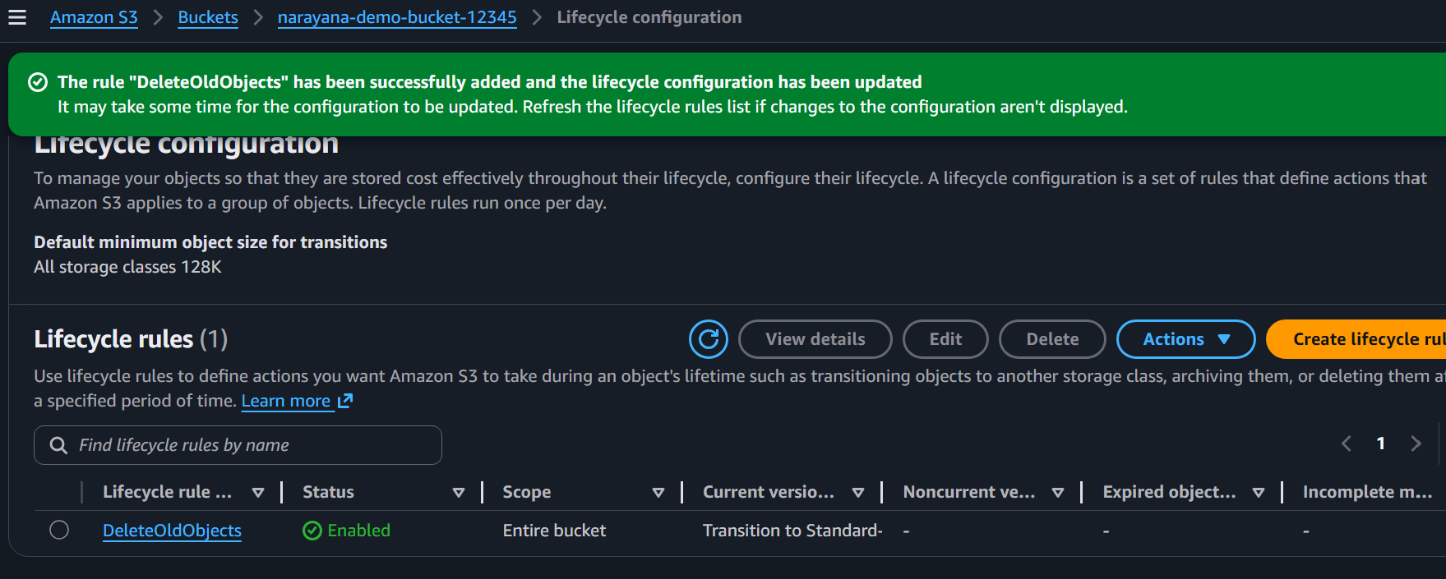

Task 6: Push Objects to S3 Using the AWS CLI (CLI)
Create sample files:
mkdir uploads
cd uploads

echo "AWS" > file1.txt
echo "DevOps" > file2.txt
echo "Amazon S3" > file3.txt
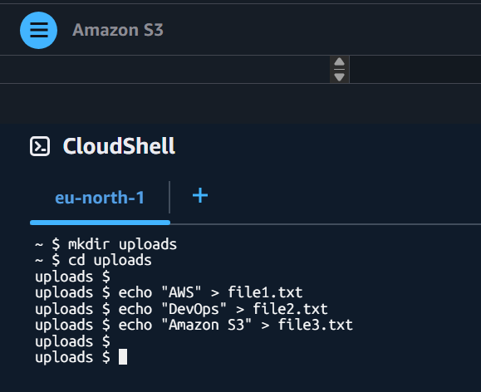
Upload all files: aws s3 cp . s3://narayana-demo-bucket-12345/ --recursive
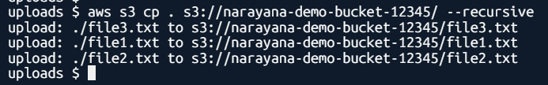
Verify: aws s3 ls s3://narayana-demo-bucket-12345/
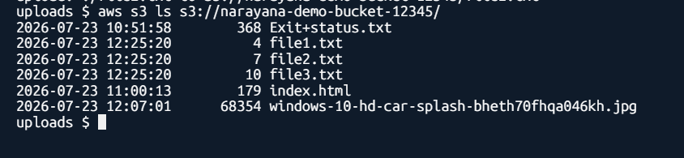
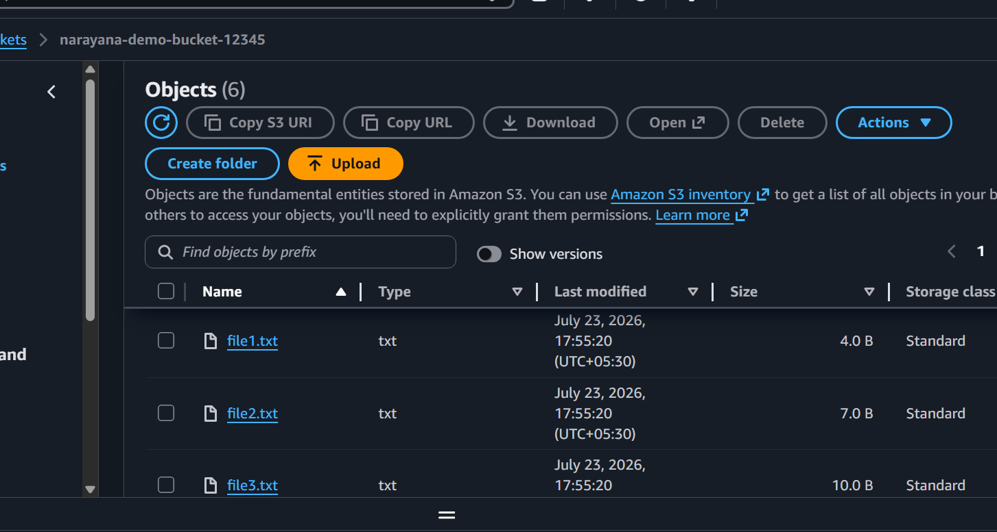
Task 7: Write a Bash Script to Create an S3 Bucket
Step 1: Go to Your Working Directory
For example, create a folder for this task:
cd ~/Desktop
mkdir s3-lab
cd s3-lab
Verify:
pwd
Example output:
/c/Users/Narayana/Desktop/s3-lab
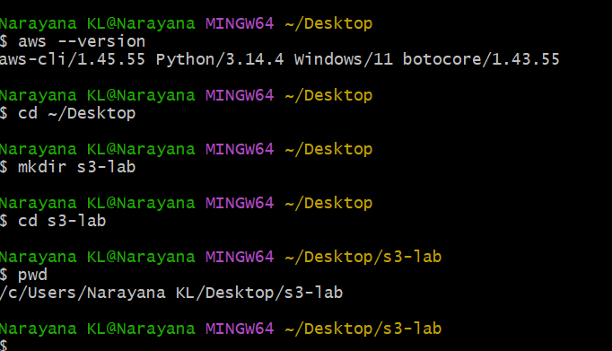

Step 2: Create the Script
touch create_bucket.sh
Verify:
ls
Output:
create_bucket.sh
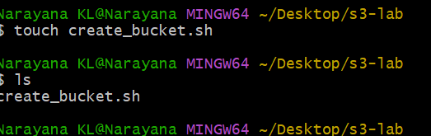

Step 3: Edit the Script
Open it with vi:
vi create_bucket.sh
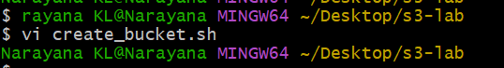
Press i to enter Insert mode, then paste:
#!/bin/bash

BUCKET_NAME="narayana-demo-$(date +%s)"
REGION="eu-north-1"

echo "===================================="
echo "Creating S3 Bucket..."
echo "Bucket Name: $BUCKET_NAME"
echo "Region: $REGION"
echo "===================================="

aws s3 mb s3://$BUCKET_NAME --region $REGION

if [ $? -eq 0 ]
then
echo ""
echo "Bucket created successfully!"
echo "Bucket Name: $BUCKET_NAME"
else
echo ""
echo "Bucket creation failed!"
fi
Save and exit:
- Press Esc
- Type:
:wq
- Press Enter
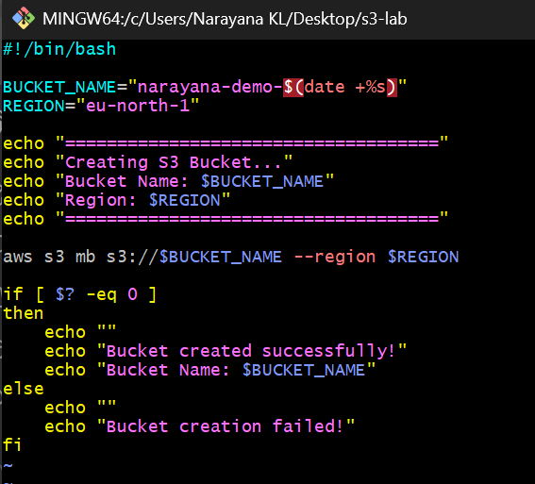

Step 4: Make the Script Executable
Run:
chmod +x create_bucket.sh
Check permissions:
ls -l
You should see something like:
-rwxr-xr-x 1 Narayana ...
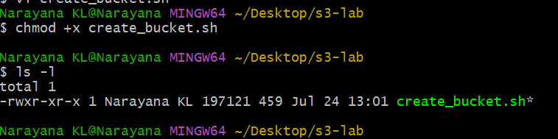

Step 5: Verify AWS Login
Before running the script, verify your AWS credentials:
aws sts get-caller-identity
If it returns your Account ID and ARN, you're ready.
If you get an error, run:
aws configure
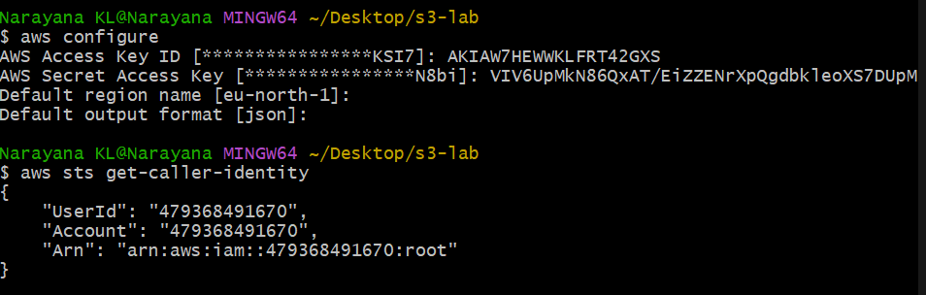

Step 6: Execute the Script
Run:
./create_bucket.sh
Expected output:
====================================
Creating S3 Bucket...
Bucket Name: narayana-demo-1753362456
Region: eu-north-1
====================================
make_bucket: narayana-demo-1753362456
Bucket created successfully!
Bucket Name: narayana-demo-1753362456
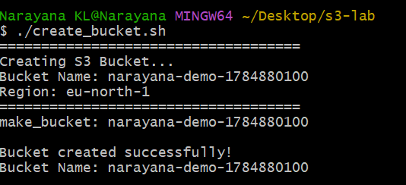

Step 7: Verify the Bucket
List your buckets:
aws s3 ls
You should see your newly created bucket, for example:
2026-07-24 12:40:21 narayana-demo-1753362456
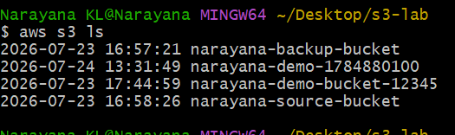
Confirm that the new bucket appears in the list.
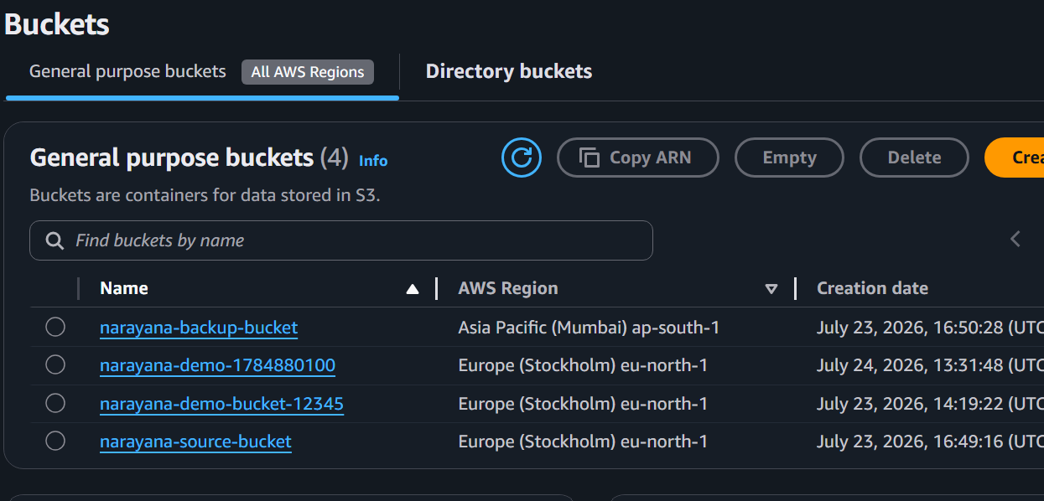
Task 8: Upload a 1 GB File to S3 Using AWS CLI
Step 1: Go to Your Working Directory
cd ~/Desktop/s3-lab

Step 2: Create a 1 GB File
Since you're using Git Bash on Windows, use the Windows fsutil command:
cmd //c "fsutil file createnew bigfile.img 1073741824"
Expected output:
File C:\Users\Narayana\Desktop\s3-lab\bigfile.img is created.
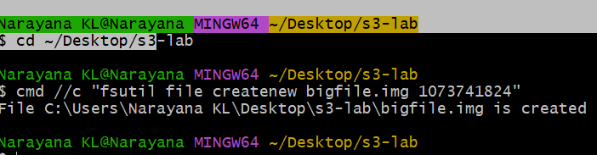

Step 3: Verify the File Size
ls -lh
Expected:
-rw-r--r-- 1 Narayana 1.0G Jul 24 16:30 bigfile.img
Or check only that file:
ls -lh bigfile.img
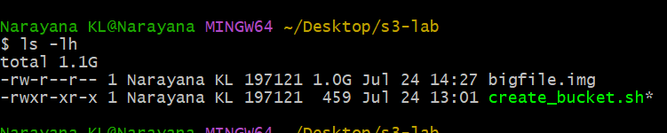

Step 4: Find Your Bucket Name
List your buckets:
aws s3 ls
Example:
2026-07-24 16:20:15 narayana-demo-1753372000
We'll use:
narayana-demo-1753372000
Replace it with your actual bucket name in the next command.

Step 5: Upload the File
aws s3 cp bigfile.img s3://YOUR-BUCKET-NAME/
Example:
aws s3 cp bigfile.img s3://narayana-demo-1753372000/
Expected output:
Completed 1.0 GiB/1.0 GiB (25.4 MiB/s) with 1 file(s) remaining
upload: ./bigfile.img to s3://narayana-demo-1753372000/bigfile.img
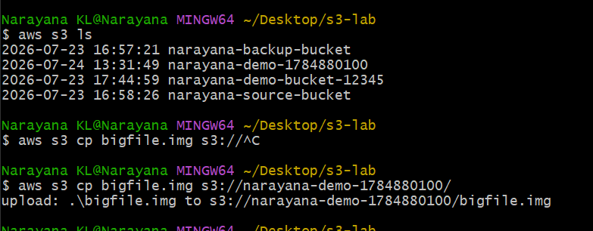

Step 6: Verify the Upload
aws s3 ls s3://YOUR-BUCKET-NAME/
Expected:
2026-07-24 16:40:30 1073741824 bigfile.img
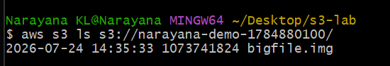

Step 7: Verify in the AWS Console
- Open AWS Console.
- Go to Amazon S3.
- Open your bucket.
- You should see:
bigfile.img
with a size of approximately 1 GB.
